Common Iowa Cover Crops

Cereal Grains

Cereal grains, like cereal rye, winter wheat, and triticale, are easily established by aerial seeding. They also tend to provide more soil erosion protection compared to brassicas.

Cereal Rye

Cereal rye is the most common cover crop in Iowa because of how much it helps conserve soil, suppresses weeds, and produces biomass. However, because of the way it holds nutrients, it can negatively impact corn yields if corn planting is less than two weeks after the rye has been terminated. Rye is winter hardy, and seed costs about $0.24 per pound.

Winter Wheat

Winter wheat is another small grain that is winter hardy. It is easier to manage in the spring than rye, and is good at retaining soil nutrients. However, it requires vernalization, or a cold snap to activate the seed’s growth, meaning it won’t emerge as early in the fall as other crops. Wheat seed costs about $0.25 per pound.

Winter Triticale

Triticale is a hybrid of wheat and rye, giving it characteristics from both. Winter triticale has a growing cycle much like winter wheat with some of the hardiness of rye. Cost for triticale seed is about $0.68 per pound.

Brassicas

Brassicas are a family of plants that include turnips and radishes. Brassicas also do well with aerial seeding. These Brassicas have large taproots that help alleviate soil compaction, and pair well with the corn or bean stalks left on the field for grazing livestock.

Turnips

Most turnips survive the winter and need to be terminated in the spring. Turnips are easy to kill in the spring, and cattle like to eat them. They grow quickly, and provide lots of biomass. Turnip seed costs about $1.65 per pound.

Radishes

Radishes have thicker bulbs than turnips, providing more organic material to the soil, but sit closer to the soil surface than turnips do. Radishes do not survive the winter, but do also grow quickly in the fall. Radish seed costs about $1.95 per pound.

Seeding Options

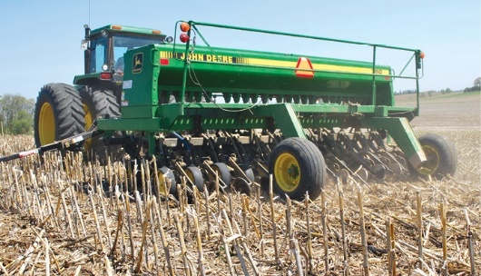No-Till Drilling

In no-till operations, seeds are often drilled into the soil. This method can also be used to plant cover crops. However, with this method, it would be important to make sure the drill can handle the correct size seeds, planting depths, and that it can handle lots of crop residue.

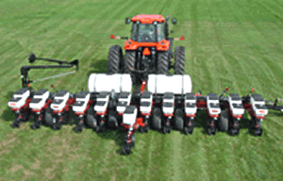

Narrow Row Planting

Many farmers have planters that can be set to 15” rows or less. These planters may be able to be equipped with seed plates for various cover crops. This method of seeding provides even and consistent planting, and helps promote fast and even emergence.

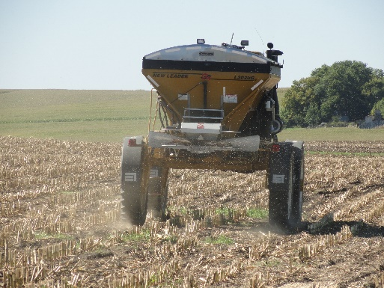Broadcast Seeding (on surface)

Broadcast seeding is simple and inexpensive, as seed is scattered across the field. However, seeding rates will need to be increased, as this method doesn’t provide high seed-to-soil contact, decreasing the percentage of seed that will become established.

Broadcast Seeding (with incorporation)

By broadcasting seed and immediately following with light tillage, a better seedbed can be prepared, increasing the percentage of seed that will establish. However, this may not be ideal for producers on no-till operations.

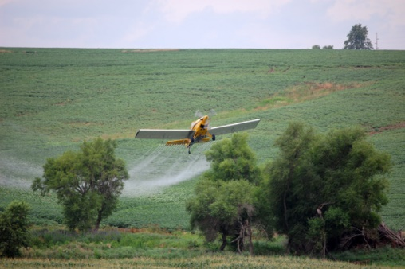

Aerial Seeding

Aerial seeding is an exciting opportunity, because it essentially eliminates soil compaction caused by driving over the field. However, it is a costly method as it requires the producer to hire a specialized pilot, and has the same issues with establishment as broadcast seeding.

Termination Options

Herbicides

Herbicides can be an effective and efficient way to terminate a crop. However, this does include a cost for the herbicide, and requires more passes through the field, which increases fuel usage, takes extra time, and can increase compaction of soil.

Grazing

If a producer has livestock, they can use their cover crops as a feed source, and graze their animals on the crop during early spring. This saves on other feed costs, and provides more benefits of the cover crop. However, if the ground gets too muddy, livestock can create ruts simply by walking through. This, and the hardiness of some crops, may increase the need for tillage before planting of the main crop.

Tillage

Crops, like weeds, can be terminated by simply tilling them under. Generally, a producer would already have the necessary equipment. However, tillage also takes time, fuel, and increases the number of passes through the field.

Rolling/crimping

Some producers terminate their cover crops by using a large roller or crimper, and pressing them down to form a mat. This isn’t the best method for all cover crop species, and not all producers may have necessary equipment, but it decreases need for herbicides, and eliminates the need for tillage.

Winter

Some cover crops do not survive winter. While this makes termination easy, it also means that more plant material will not be added in the early spring months.